Tues, Sept 3
2 PM
JMB rm 230,
Shelby campus

STEM Club

Interest Meeting
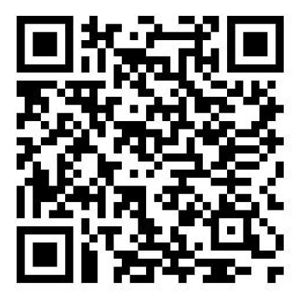
All welcome regardless of major!
Learn about careers and make STEM friends!

